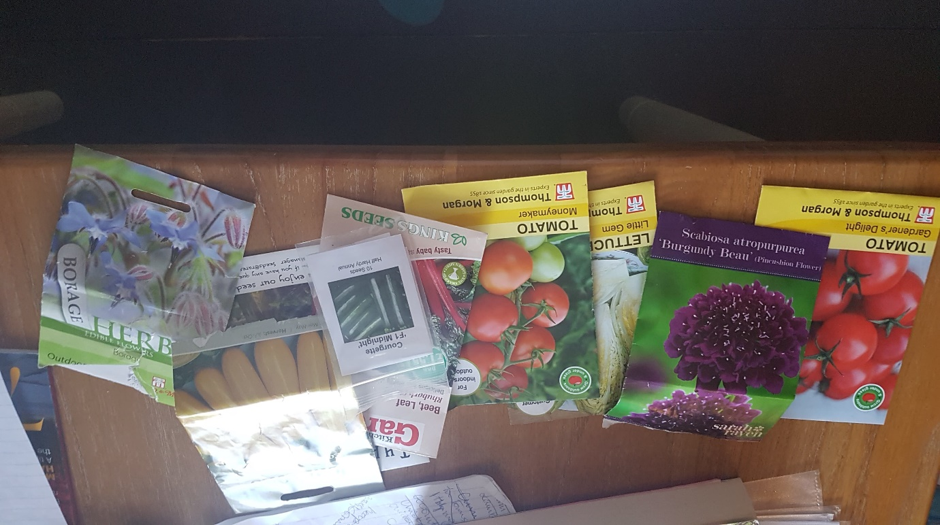

*Vegetable and herb seeds given to my mum by the community*

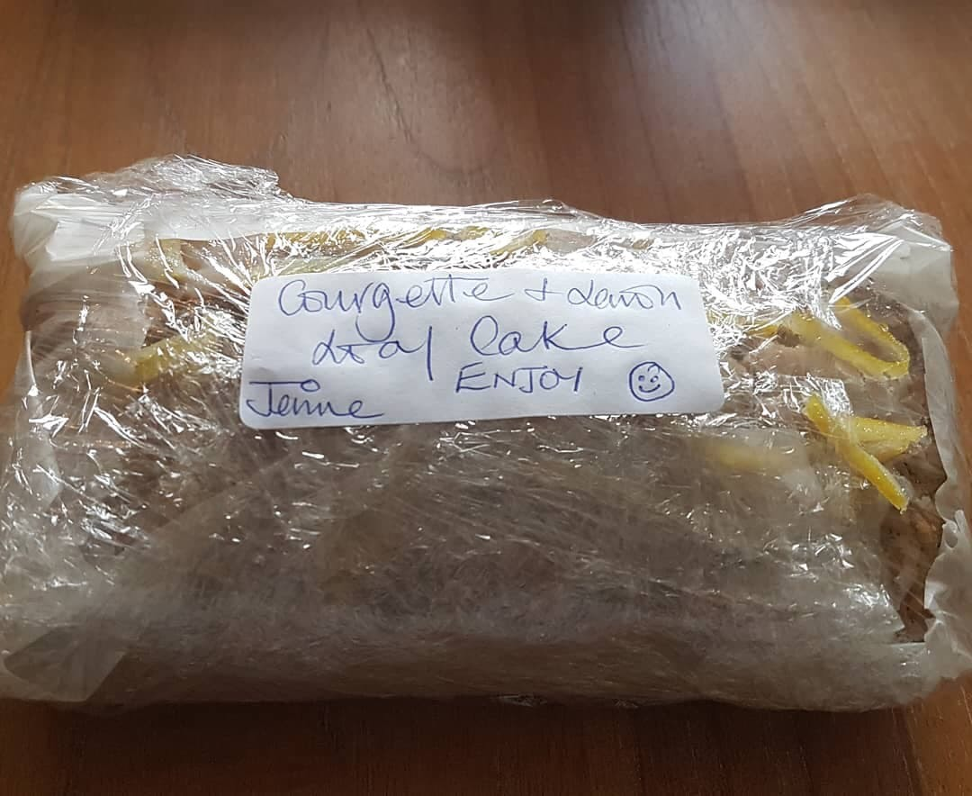

*Courgette and Lemon cake home baked*

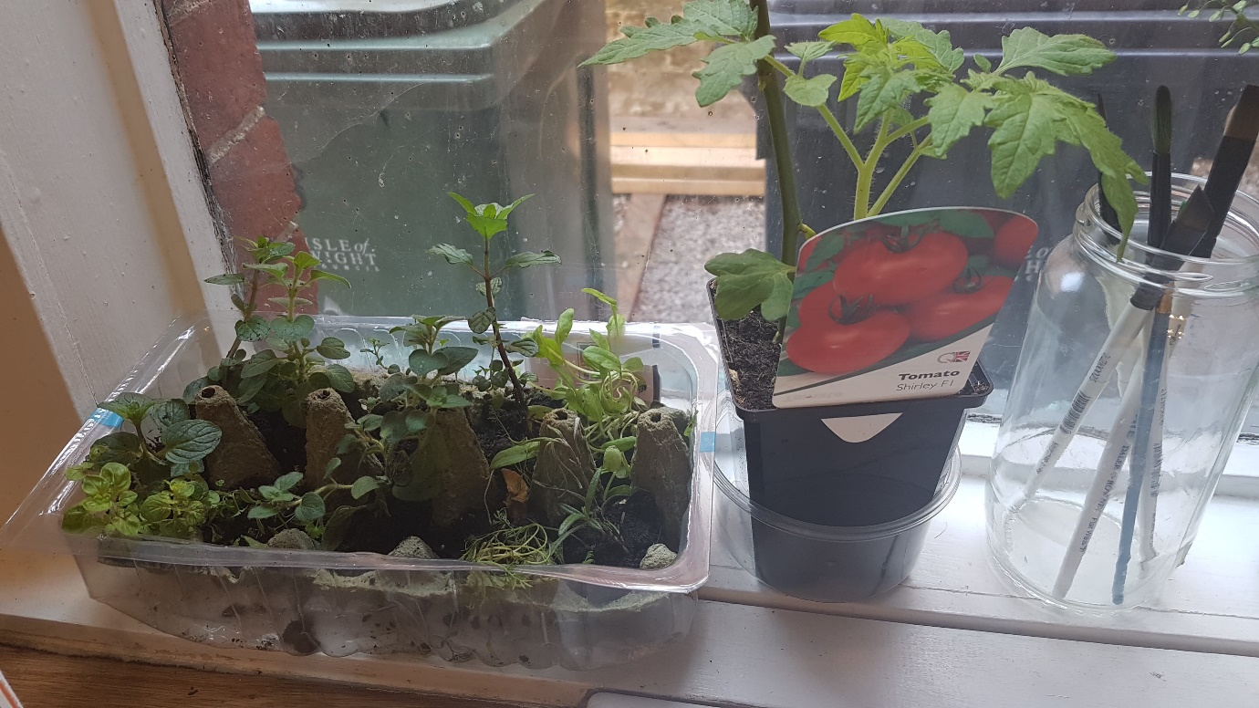

Herbs saplings growing, ready for planting in mums new veg plot

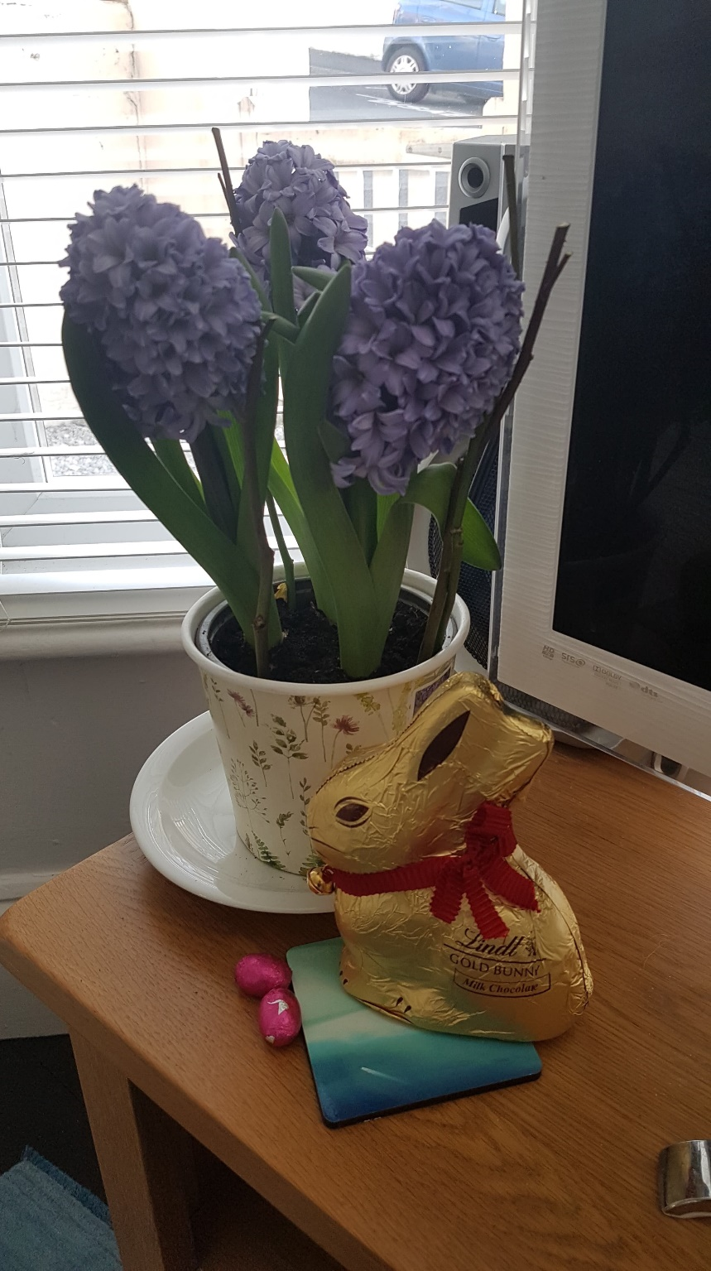

Hyacinths and chocolate bunnies to spread some cheer!



*Stanley the naughty beagle pup!*

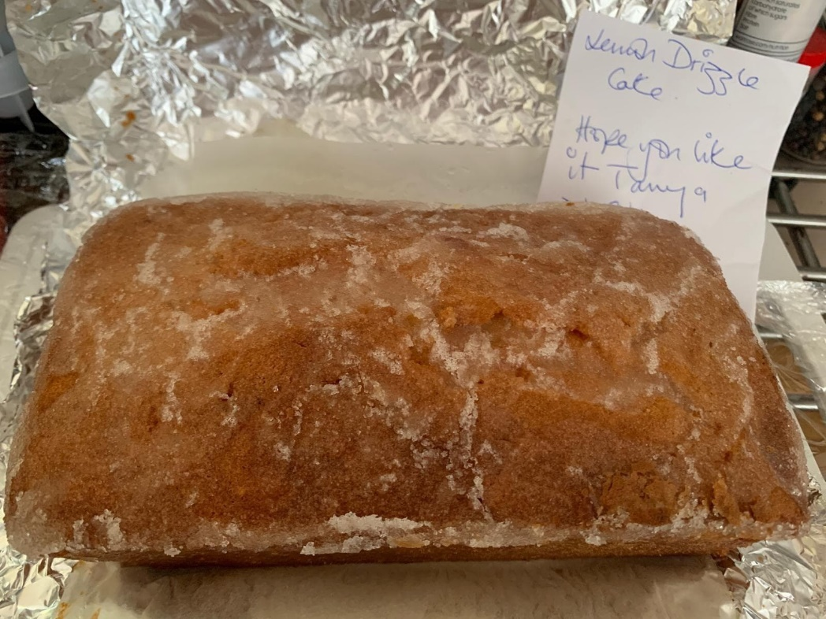

*Jennies Lemon Drizzle Cake*